Step 1: create a snow Pipe for the Functionality  
// Define pipe

CREATE OR REPLACE pipe DEV_DB.PIPES.employee_pipe

auto_ingest = TRUE

AS

COPY INTO DEV_DB.PUBLIC.employees_snowpipe FROM @DEV_DB.PUBLIC.employees_stage;  
  
  
Step 2: From description get the notification channel of the snowpipe

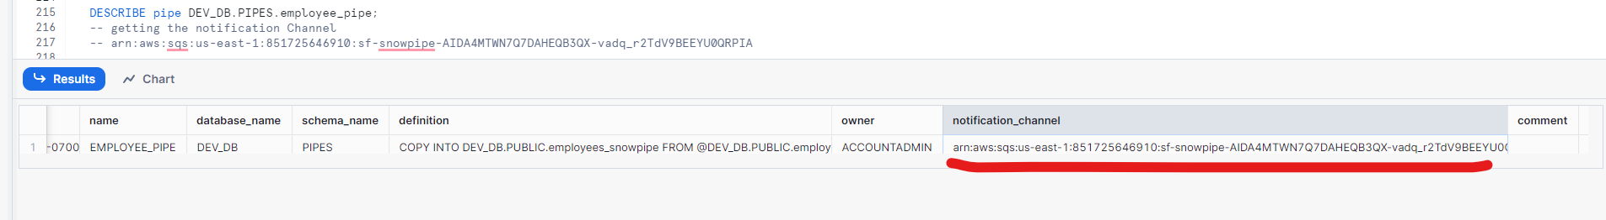

Step 3: Create a S3 bucket Notifications

1. Go to the respective bucket properties  
   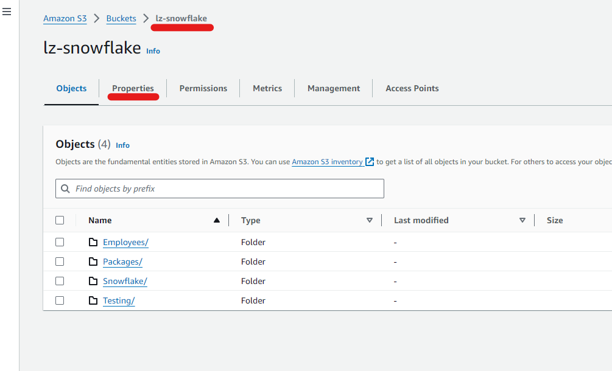
2. Click Create event Notification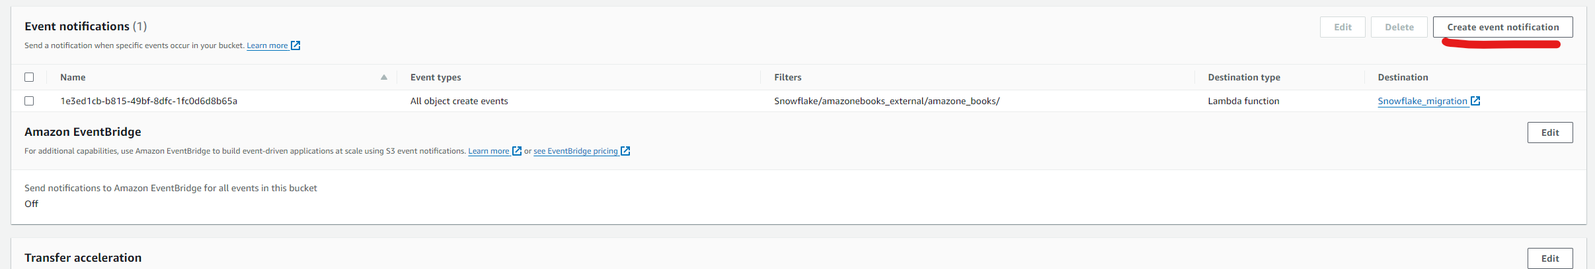
3. Type the relevant name for the Notification
4. Enter the Prefix (Optional)
5. Select Events Types  
   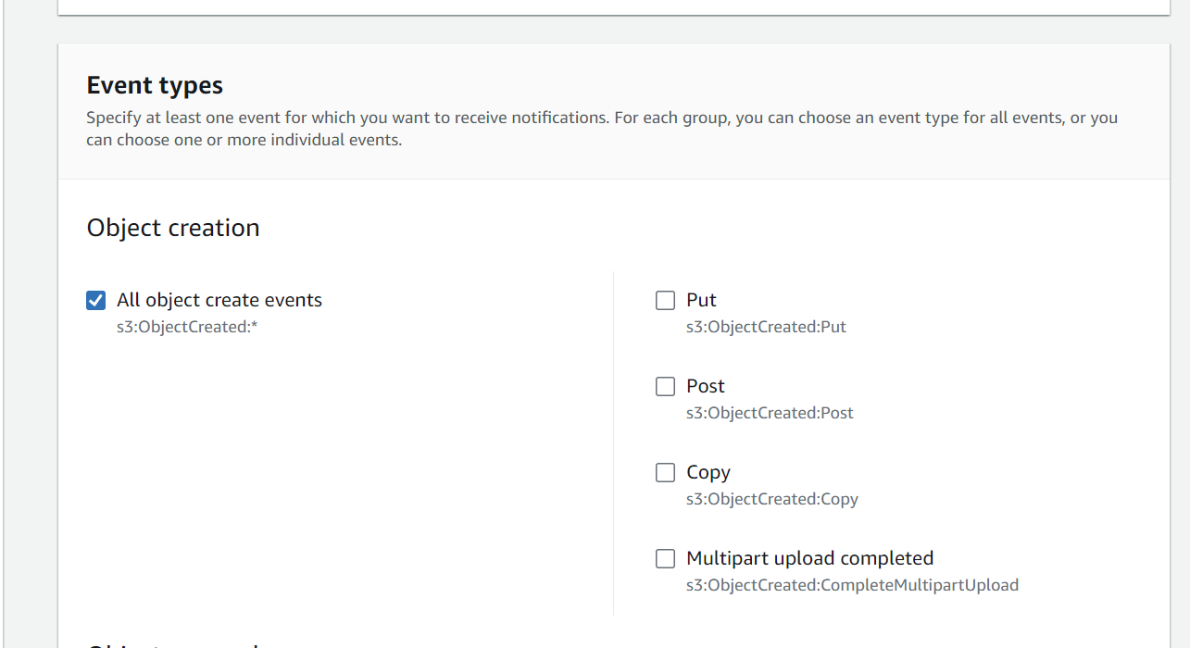
6. Scroll down to Destination  
   select SQS queue  
   select Enter SQS queue  
   paste the Snowpipe notification channel  
   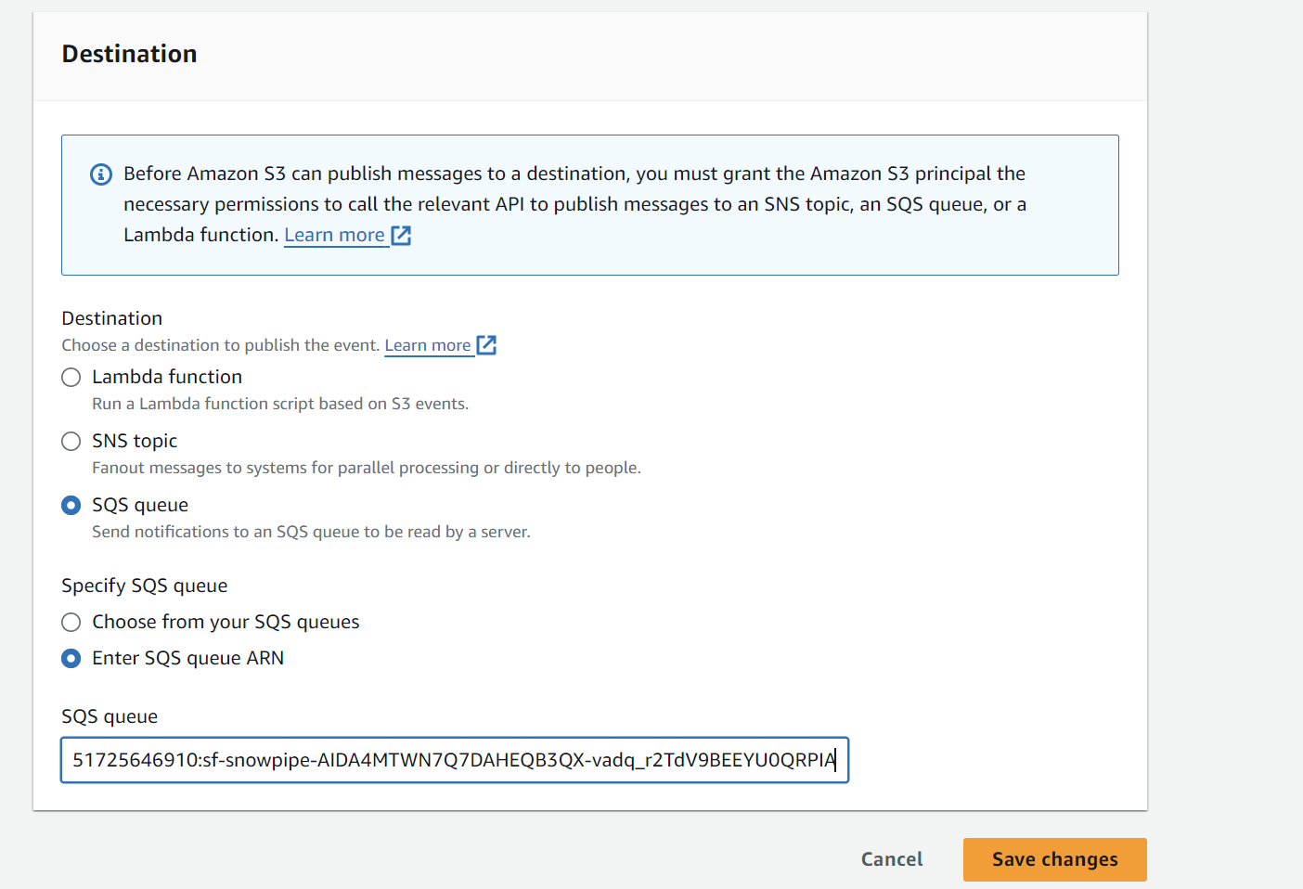
7. Save the Notification